**Part a)**

-After Phase 1

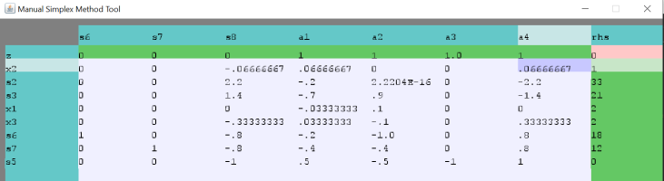

-After phase 2, optimal point is in the following:

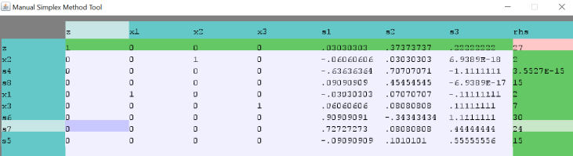

**Part b)**

-After phase 1, infeasible:

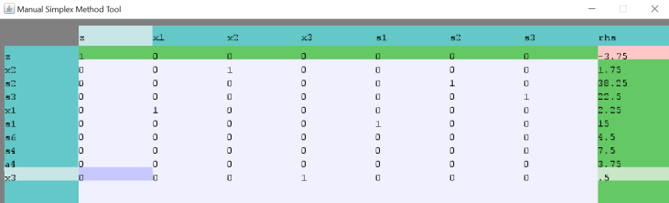

**Part c)**

-After Phase 1

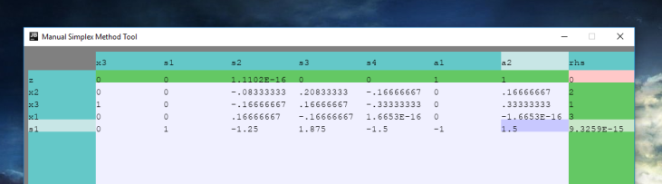

-After Phase 2: unbounded

